**IOT Project Report**



**Smart Electronic Voting Machine**

**Using Arduino**

**Submitted by**

**Name- Anuj Aggarwal**

**Roll No.- 17csu030**

**Table of Contents**

[1 Smart Electronic Voting Machine Using Arduino](https://www.how2electronics.com/smart-electronic-voting-machine-using-arduino/#Smart_Electronic_Voting_Machine_Using_Arduino)

[2 Components Required](https://www.how2electronics.com/smart-electronic-voting-machine-using-arduino/#Components_Required)

[3 Block Diagram](https://www.how2electronics.com/smart-electronic-voting-machine-using-arduino/#Block_Diagram)

[4 Circuit Diagram](https://www.how2electronics.com/smart-electronic-voting-machine-using-arduino/#Circuit_Diagram)

[5 Working of the Project](https://www.how2electronics.com/smart-electronic-voting-machine-using-arduino/#Working_of_the_Project)

[6 Source Code/Program](https://www.how2electronics.com/smart-electronic-voting-machine-using-arduino/#Source_CodeProgram)

### ****Smart Electronic Voting Machine Using Arduino****

This project is all about Simple & Smart Electronic Voting Machine Using Arduino. The basic idea of this project is to create an electronic voting machine that will help to eradicate defrauding of the manual voting systems and prior versions of electronic voting.

The system is provided with n number of switch where n is the number of political party. Here the voter will be allowed to proceed for choosing their preferred candidate from the panel of buttons. The final vote is then displayed onto a LCD for the satisfaction of voters. At the end the result can be automatically calculated by pressing result button.

### ****Components Required****

1. Arduino UNO Board

2. 16X2 LCD Display

3. 4 Push buttons

4. 10K POT

5. Connecting Wires

6. Breadboard

### ****Block Diagram****

[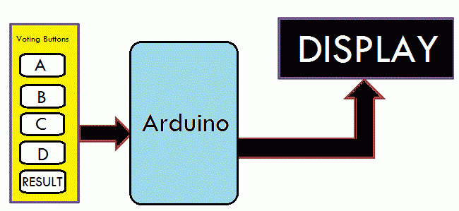](https://i2.wp.com/www.how2electronics.com/wp-content/uploads/2019/04/Block-Diagram-Electronic-Voting-Machine-Using-Arduino.gif?ssl=1)

In this project, i.e Smart Electronic Voting Machine Using Arduino, we have used four push buttons for four different candidates who are taking part in election. We can increase the number of candidate as per requirement. When any voter press any of four button then respecting voting value will increment by one each time. After whole voting process the result button can be pressed to display the result.

### ****Circuit Diagram****

[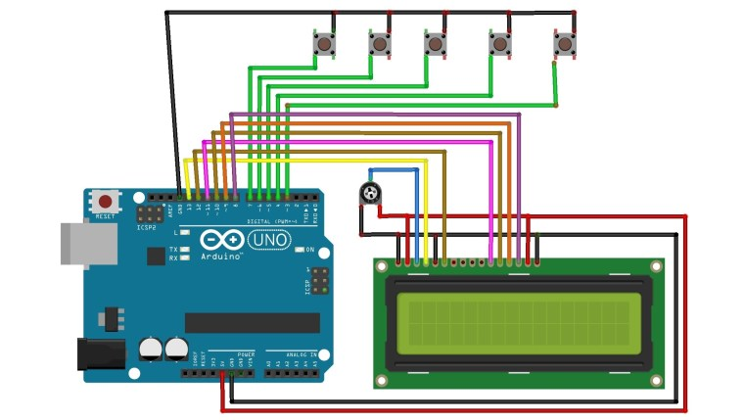](https://i1.wp.com/www.how2electronics.com/wp-content/uploads/2019/04/Circuit-Diagram.jpg?ssl=1)

Assemble the circuit as shown in the figure above. Connect the 5 push buttons to digital pin 7,6,5,4,3 of Arduino. Similarly connect pin 4,6, 11, 12, 13, 14 of LCD to digital pin 13, 12, 11, 10, 9, 8 of Arduino.

### ****Working of the Project****

Here Arduino is the heart and brain of this system. Arduino controls the complete voting processes like reading button, incrementing vote value, generating result and sending vote and result to LCD Display.

Here we have added five buttons which are assigned for team A, team B, team C, team D and last button is used for calculating or displaying results.

Below are some of the pictures for this projet that tells the clear story about working of this project.

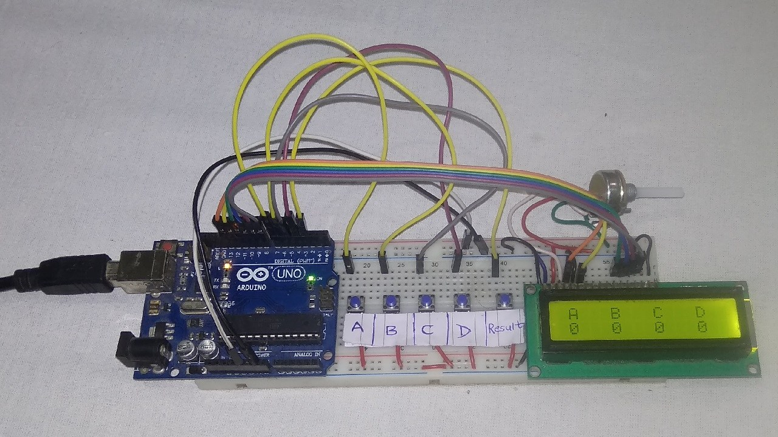

### ****Source Code/Program****

#include<LiquidCrystal.h>

LiquidCrystal lcd(13, 12, 11, 10, 9, 8);

#define S1 7

#define S2 6

#define S3 5

#define S4 4

#define S5 3

int vote1=0;

int vote2=0;

int vote3=0;

int vote4=0;

void setup()

{

pinMode(S1, INPUT);

pinMode(S2,INPUT);

pinMode(S3,INPUT);

pinMode(S4,INPUT);

pinMode(S5,INPUT);

lcd.begin(16, 2);

lcd.print(" Electronic ");

lcd.setCursor(0,1);

lcd.print(" Voting Machine ");

delay(4000);

digitalWrite(S1, HIGH);

digitalWrite(S2, HIGH);

digitalWrite(S3, HIGH);

digitalWrite(S4, HIGH);

digitalWrite(S5, HIGH);

lcd.clear();

lcd.setCursor(1,0);

lcd.print("A");

lcd.setCursor(5,0);

lcd.print("B");

lcd.setCursor(9,0);

lcd.print("C");

lcd.setCursor(13,0);

lcd.print("D");

}

void loop()

{

lcd.setCursor(1,0);

lcd.print("A");

lcd.setCursor(1,1);

lcd.print(vote1);

lcd.setCursor(5,0);

lcd.print("B");

lcd.setCursor(5,1);

lcd.print(vote2);

lcd.setCursor(9,0);

lcd.print("C");

lcd.setCursor(9,1);

lcd.print(vote3);

lcd.setCursor(13,0);

lcd.print("D");

lcd.setCursor(13,1);

lcd.print(vote4);

if(digitalRead(S1)==0)

vote1++;

while(digitalRead(S1)==0);

if(digitalRead(S2)==0)

vote2++;

while(digitalRead(S2)==0);

if(digitalRead(S3)==0)

vote3++;

while(digitalRead(S3)==0);

if(digitalRead(S4)==0)

vote4++;

while(digitalRead(S4)==0);

if(digitalRead(S5)==0)

{

int vote=vote1+vote2+vote3+vote4;

if(vote)

{

if((vote1 > vote2 && vote1 > vote3 && vote1 > vote4))

{

lcd.clear();

lcd.print("A is Winner");

delay(3000);

lcd.clear();

}

else if((vote2 > vote1 && vote2 > vote3 && vote2 > vote4))

{

lcd.clear();

lcd.print("B is Winner");

delay(3000);

lcd.clear();

}

else if((vote3 > vote1 && vote3 > vote2 && vote3 > vote4))

{

lcd.clear();

lcd.print("C is Winner");

delay(3000);

lcd.clear();

}

else if(vote4 > vote1 && vote4 > vote2 && vote4 > vote3)

{

lcd.setCursor(0,0);

lcd.clear();

lcd.print("D is Winner");

delay(3000);

lcd.clear();

}

else if(vote4 > vote1 && vote4 > vote2 && vote4 > vote3)

{

lcd.setCursor(0,0);

lcd.clear();

lcd.print("D is Winner");

delay(3000);

lcd.clear();

}

else

{

lcd.clear();

lcd.print(" Tie Up Or ");

lcd.setCursor(0,1);

lcd.print(" No Result ");

delay(3000);

lcd.clear();

}

}

else

{

lcd.clear();

lcd.print("No Voting....");

delay(3000);

lcd.clear();

}

vote1=0;vote2=0;vote3=0;vote4=0,vote=0;

lcd.clear();

}

}